* **This Interview Success Journal is the 1st of 3 Success Journals in this Course. This Success Journal is the exercise book for Sections 1-23 of this course.**
* The purpose of this Interview Success Journal is make sure that you are incredibly well prepared for your upcoming interview.
* Please watch the videos in the course & then complete sections of this journal when instructed to do so.
* After completing the Interview portion of this course (Sections 1-23) and this Interview Success Journal, you will have the confidence to do exceptionally well in your interview! After you complete this journal, move on to Journal #2 and then #3. Thanks

Part 1 of 3: Interview

Success

Journal

Your Blueprint

to Your Dream Job

From the Course:

*The Complete Job, Interview, Resume, Network & New Career Guide*

Please use the PDF version of this document if you don’t have access to Microsoft Word or if you prefer a PDF formatted document for the device you are using to take this course. Thanks

Welcome to your **Interview Success Journal** (the first of 3 success journals in this course)!

*Please only complete the exercises in this journal when instructed to do so (meaning when I mention to please do so in the videos). Thanks

Please note that this Interview Success Journal is the first of 3 journals in this course and corresponds to Sections 1 – 23 of the course.

After completing the Interview Success Journal, please complete the 2nd Journal, which corresponds to Sections 24 – 41 in the course and is called:

**\* Part 2 of 3: Resume, LinkedIn and Career Success Journal**

After completing the two previous journals, please complete the 3rd Journal, which corresponds to Sections 42 – 50 in the course and is called:

**\* Part 3 of 3: Networking Success Journal**

I humbly recommend taking the course in order and completing the 3 Success Journals in order because you might learn what to include and what not to include on your resume and optimized LinkedIn profile based on how you answer the interview questions in Part 1 of this course.

As always, I am here to help if you have any questions.

Enjoy the course! Thanks,

Chris Haroun

: )

After you complete this comprehensive Interview Success Journal, you can refer to it and read it a few days before your interview (or even the morning of your interview) so that you are much more prepared than the competition is.

***\**** *Although I recommend doing the entire course in order, if you feel very very comfortable with your interview skills then please jump to section 2 or 3.*

## **Section #1**:

## Introduction to Getting Your Dream Job and How to Take this Course

## **Interview Success Journal exercise #1:**

## Let's Find Out What Your Weaknesses Are Right Now

After you watch all of Section 1 in the course, please do the exercise below.

Please select Yes or No to the following weaknesses that you might have and we will discuss how to address these perceived weaknesses in the next section of the course (if you are using Microsoft Word, please delete the word NO if your answer is YES and vice versa):

1. YES / NO: You don’t think you have enough work experience to get the job.
2. YES / NO: You don’t think you have the right education to get the job.
3. YES / NO: You have had too many jobs for short periods of time (meaning full time   
    jobs where you stayed at that job for less than 1 year).
4. YES / NO: You were fired.
5. YES / NO: You were unemployed or didn’t work for an extended period of time.
6. YES / NO: You think you are too young.
7. YES / NO: You think you are too old.
8. YES / NO: You are overqualified for the job.
9. YES / NO: You might not have the right work visa.
10. YES / NO: You don't have the right background or life experiences.

1. YES / NO: You have worked in industries that have nothing to do with the job you are   
    interviewing for.
2. YES / NO: You don’t have enough confidence to do well in interviews.
3. YES / NO : Something happened to you or something that you did when you were   
    younger might stop you from getting hired.
4. YES / NO: Your grades or test scores aren't high enough.

|  |
| --- |
| 15. YES / NO: *Other: |
|  |
|  |
|  |

|  |
| --- |
| 16. YES / NO: *Other: |
|  |
|  |
|  |

|  |
| --- |
| 17. YES / NO: *Other: |
|  |
|  |
|  |

|  |
| --- |
| 18. YES / NO: *Other: |
|  |
|  |
|  |

|  |
| --- |
| 19. YES / NO: *Other: |
|  |
|  |
|  |

|  |
| --- |
| 20. YES / NO: *Other: |
|  |
|  |
|  |

* Please let me know right away if the reason you think you won’t get a job isn’t included in the list above and I will immediately add a video or address the topic(s) in the course or offline if you want to send me a message directly (I really want to help you). Thanks

**Next Step**: Please watch the next video in the course to see how we can address these issues and potentially turn these weaknesses into strength(s) before doing the next exercise. Thanks

## **Section #2**:

## Turning Your Weaknesses Into Strengths

## **Interview Success Journal exercise #2:** let’s address your weaknesses and see if we can turn them into strengths!

During Section 2 of the course, please do the exercise below.

If you selected Yes or No to any of the weaknesses in the previous section, please write down in the space provided below how you can address/discuss your perceived weaknesses during the interview. The goal here is to try to make the weakness seem like a strength or even an admirable quality when you are discussing them in the interview.

Please feel free to watch the corresponding weakness lecture in this section before, during or after you complete each question in this exercise.

Please keep your answers very short as interviewers prefer short answers (less is always more):

|  |
| --- |
| 1. YES / NO: You don’t think you have enough work experience to get the job. |
|  |
|  |
|  |

|  |
| --- |
| 2. YES / NO: You don’t think you have the right education to get the job. |
|  |
|  |
|  |

|  |
| --- |
| 3. YES / NO: You have had too many jobs for short periods of time (meaning full   time jobs where you stayed at that job for less than 1 year). |
|  |
|  |
|  |

|  |
| --- |
| 4. YES / NO: You were fired. |
|  |
|  |
|  |

|  |
| --- |
| 5. YES / NO: You were unemployed or didn’t work for an extended period of time. |
|  |
|  |
|  |

|  |
| --- |
| 6. YES / NO: You think you are too young. |
|  |
|  |
|  |

|  |
| --- |
| 7. YES / NO: You think you are too old. |
|  |
|  |
|  |

|  |
| --- |
| 8. YES / NO: You are overqualified for the job. |
|  |
|  |
|  |

|  |
| --- |
| 9. YES / NO: You might not have the right work visa. |
|  |
|  |
|  |

|  |
| --- |
| 10. YES / NO: You don't have the right background or life experiences. |
|  |
|  |
|  |

|  |
| --- |
| 11. YES / NO: You have worked in industries that have nothing to do with the job   you are interviewing for. |
|  |
|  |
|  |

|  |
| --- |
| 12. YES / NO: You don’t have enough confidence to do well in interviews. |
|  |
|  |
|  |

|  |
| --- |
| 13. YES / NO: Your grades or test scores aren't high enough. |
|  |
|  |
|  |

|  |
| --- |
| 14. YES / NO: Something happened to you or something that you did when you   were younger might stop you from getting hired. |
|  |
|  |
|  |

|  |
| --- |
| 15. YES / NO: *Other |
|  |
|  |
|  |

|  |
| --- |
| 16. YES / NO: *Other |
|  |
|  |
|  |

|  |
| --- |
| 17. YES / NO: *Other |
|  |
|  |
|  |

|  |
| --- |
| 18. YES / NO: *Other |
|  |
|  |
|  |

|  |
| --- |
| 19. YES / NO: *Other |
|  |
|  |
|  |

|  |
| --- |
| 20. YES / NO: *Other |
|  |
|  |
|  |

* Please let me know right away if the reason you think you won’t get a job isn’t included in the list above and I will immediately add a video or address the topic(s) in the course or offline if you want to send me a message directly (I really want to help you). Thanks

**Next Step**: We have finished the hardest part! Please watch the next video in the course to see how we can discuss your strengths before doing the next exercise. Thanks

## **Section #3**:

## What Are Your Strengths & How to Ace Questions About What You are Good At

## **exercise #3.1:**

## What Your Strengths Are & How to Address Them

During Section 3 of the course, please do the exercise below (you can complete it before, during or after the lectures taught in this section).

Please write beside/under each strength listed below at least one thing about you and your past experience (work or non work related) that you feel represents this strength quality that you can talk about in an interview (make it sound interesting please). Thanks

|  |
| --- |
| 1. Teamwork: |
|  |
|  |

|  |
| --- |
| 2. Passion (meaning you were born to do this job as this job is your passion): |
|  |
|  |

|  |
| --- |
| 3. Dedication & Hard Work: |
|  |
|  |

|  |
| --- |
| 4. Enjoy: |
|  |
|  |

|  |
| --- |
| 5. Exceed Expectations: |
|  |
|  |

|  |
| --- |
| 6. Dependable: |
|  |
|  |

|  |
| --- |
| 7. Organized: |
|  |
|  |

|  |
| --- |
| 8. Customer Focused: |
|  |
|  |

|  |
| --- |
| 9. What Makes You Different or Unique When Compared to Other Candidates for this   Job? |
|  |
|  |

|  |
| --- |
| 10. Why Has Everything You Have Done in Your Life Lead You to Excel at This Job? |
|  |
|  |

|  |
| --- |
| 11. Other: |
|  |
|  |

|  |
| --- |
| 12. Other: |
|  |
|  |

|  |
| --- |
| 13. Other: |
|  |
|  |

|  |
| --- |
| 14. Other: |
|  |
|  |

**Next Step:** Please watch the next video in the course before doing the next exercise. Thanks

**Exercise #3.2: Put Additional Strength Key Words Into Answers**

For each of the following strength key words, list 2-3 things that you have done in the past or about you that shows a good example of the key word in action. If you are having trouble with this exercise, then simply write a sentence using the term. For example, for A: Humble (see below), you can write “I am very humbled to be given the opportunity to interview at this company because I am passionate about……”:

|  |
| --- |
| **A**: Humble: |
| 1: |
| 2: |
| 3: |

|  |
| --- |
| **B**: Ethical: |
| 1: |
| 2: |
| 3: |

|  |
| --- |
| **C**: Multitask: |
| 1: |
| 2: |
| 3: |

|  |
| --- |
| **D**: Generous/Charitable: |
| 1: |
| 2: |
| 3: |

**Next Step**: Now that we have covered your strengths and weaknesses, please watch the next video in the course before doing the next exercise, which covers what to bring to the interview (including impressive documents that your competitors will not bring). Thanks

## **Section #4**:

## What to Bring to the Interview to Increase Your Chances of Getting Hired

## **exercise #4:**

## What to Bring Checklist and Discussion

There are 2 parts to the exercise.

1. **Exercise 4.1**: The first part deals with what items to bring (please watch the videos in section 4 to understand why and for more details).
2. **Exercises 4.2 to 4.8:** The second part contains templates that you can complete if applicable to the job you are interviewing for. The goal is to only pull these items out of your bag if you discuss these items in the interview. You will look **SOOOOOOOOO** good if the interviewer asks you a questions and you respond with *“I am glad you asked this question as I brought a write-up for you on my thoughts on this topic!”*

**Exercise 4.1: What to Bring in Your Bag Checklist:** (per the video discussions in this course)

* 10 copies of your resume as many times the interviewers are disorganized and they don’t have copies of your resume on hand…..this will make you look prepared if they ask for it. We will cover how to create an impactful resume and LinkedIn profile later in this course (I want to first cover all topics you can be asked in interviews so we can make/change/improve your resume based on what we learn about interviewing).
* 3 nutribars as many times your interviewers will forget to feed you if you have many unanticipated back to back to back interviews. When I interviewed at Goldman Sachs, this is what happened to me. You can quickly eat the nutribar for more energy while you are on a short break or between interviews when you are sitting idle in the interview room.

Don’t purchase ones that make a mess like these ones

….sorry – trying to be funny here : )



* 1 water bottle container which you can keep in your bag and drink in between interviews if the interviewer forgets to offer you water (this does happen…..let’s be ready as every battle is won before it has been fought)!
* 1 notebook as you need to write down follow up items in the interview if you can’t answer a question (we will also cover how to deal with questions we can’t answer later in the course and why you need to follow up with the interviewers). This brand is professional enough to bring and you can purchase it from Amazon:
  + <https://www.amazon.com/Moleskine-Classic-Notebook-Large-Notebooks/dp/8883701127/ref=sr_1_1?s=books&ie=UTF8&qid=1468718463&sr=1-1&keywords=notebook>
  + 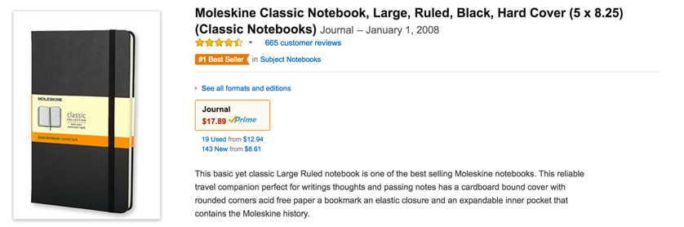
* I don’t want to take any chances and as bizarre as this sounds, having the wrong pen can negatively impact your interviewer’s perception of you. I had a friend that once used a pen with a logo of a competitor or a logo of a company in a completely different industry, which the interviewer mentioned in the interview. To quote the late great former CEO off Intel, Andy Grove, ‘only the paranoid survive.’ As such, here is a safe option, also available from Amazon (it has a stylus option for free in case you are taking notes on a tablet or on an iPad):
  + <https://www.amazon.com/iDream365-Stainstainless-Capacitive-Smartphones-Box-Black/dp/B00ZXN8G46/ref=sr_1_16?ie=UTF8&qid=1468718698&sr=8-16&keywords=pen>
  + 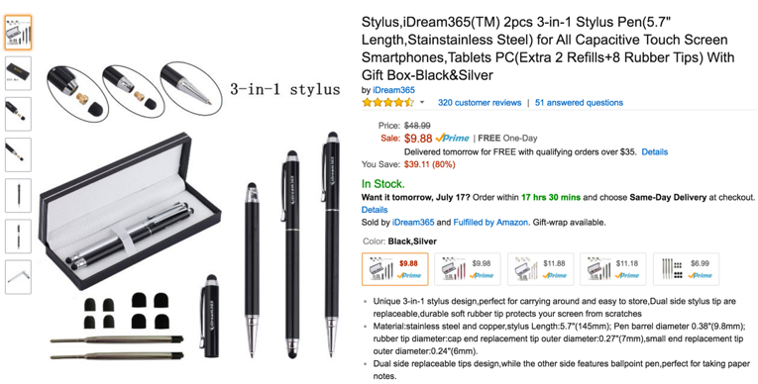
* A classy/conservative bag to carry your interview items in. Here is an image from Amazon of a simplistic bag. I am not including the link because I think you can find a cheaper and maybe slightly slimmer version elsewhere:
  + 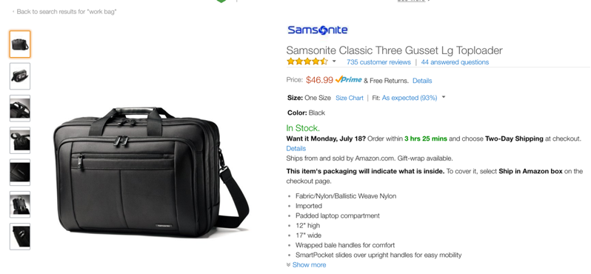
* Please purchase folders like the ones at this Amazon link and image below so you look exceptionally organized for your interview when you pull out the appropriate completed template(s):
  + <https://www.amazon.com/Pendaflex-Folders-InfoPocket-Letter-Assorted/dp/B000AN1QDM/ref=sr_1_4?s=office-products&ie=UTF8&qid=1468719872&sr=1-4&keywords=folders>
  + 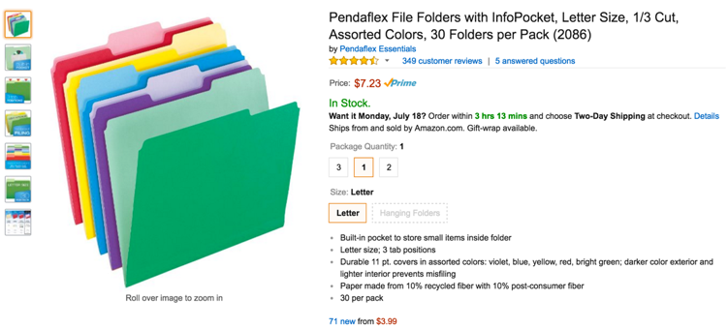

**What Templates to Create and Bring in Your Bag:** (per the video discussions in this course)

Bring 10 copies of each template that you complete per the example templates shown on the next few pages. Please watch the videos in this Section (Section 4) for more details and please remember that we are doing this extra work because our competition will not.

Please note that ‘less is more’ and your interviewer will prefer a simple 1-page write-up per the templates shown on the next few pages and not a multi page report.

Please only pull these items out in the interview if you are asked about a topic that the template you complete covers or if it feels appropriate to do so. Trust me – nobody does this and this will make you shine and this will significantly increase your chances of getting hired!

**Next Step:** Please watch the next video in the course before doing exercise 4.2. Thanks

* **Exercise 4.2: If you are interviewing for an investment job**, consider making or completing a few investment idea templates on what your favorite investment ideas are using the template on the next page, which is also attached in this section and deals with why a certain investment is worth considering investing in (I teach Udemy courses on investments that cover these topics in much more detail). Please note, you can find out at [www.sec.gov](http://www.sec.gov) (or other government public market websites) what investments a company owns and then create one pagers on their top 5 positions and your thoughts on each; in fact, you are almost guaranteed to be asked a question about what they own if the person that is responsible for that investment position interviews you. For more details on how to use [www.sec.gov](http://www.sec.gov) or other websites to find out what companies the investment firm has invested in, please ask me in the course notes. The interview looks like this (please see below):

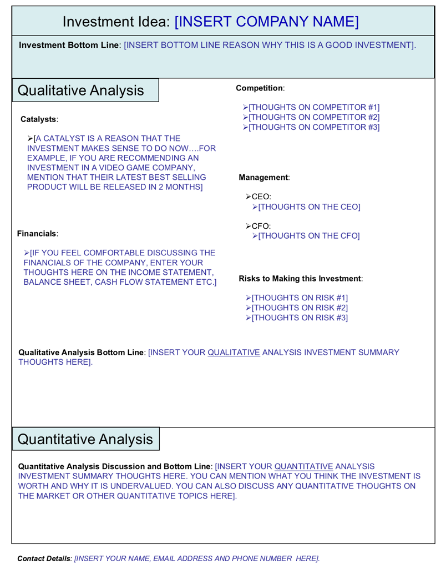

This document is attached to this lecture and is called: “**Template_Investment_Interview.ppt**”  
In addition to printing this out and bringing multiple copies of it to your interview, you can save this document as a PDF in PowerPoint and email it to people you have already interviewed with in your Thank You email. Alternatively, as a follow up a few days after your interview or if it has been 1-2 weeks and you have not heard back from your interviewer(s), consider attaching this document in an email and sending it to the person/people that interviewed you [assuming you didn’t give them a paper copy in your interview]. You can also make a brand new one and send it to them that covers a different topic.

**Next Step:** Please watch the next video in the course before doing exercise 4.3. Thanks

* **Exercise 4.3: If you are interviewing for a management or a business development job**, consider completing the following template which is attached in this section; this template expresses a great business development, management or other idea (included in this course):

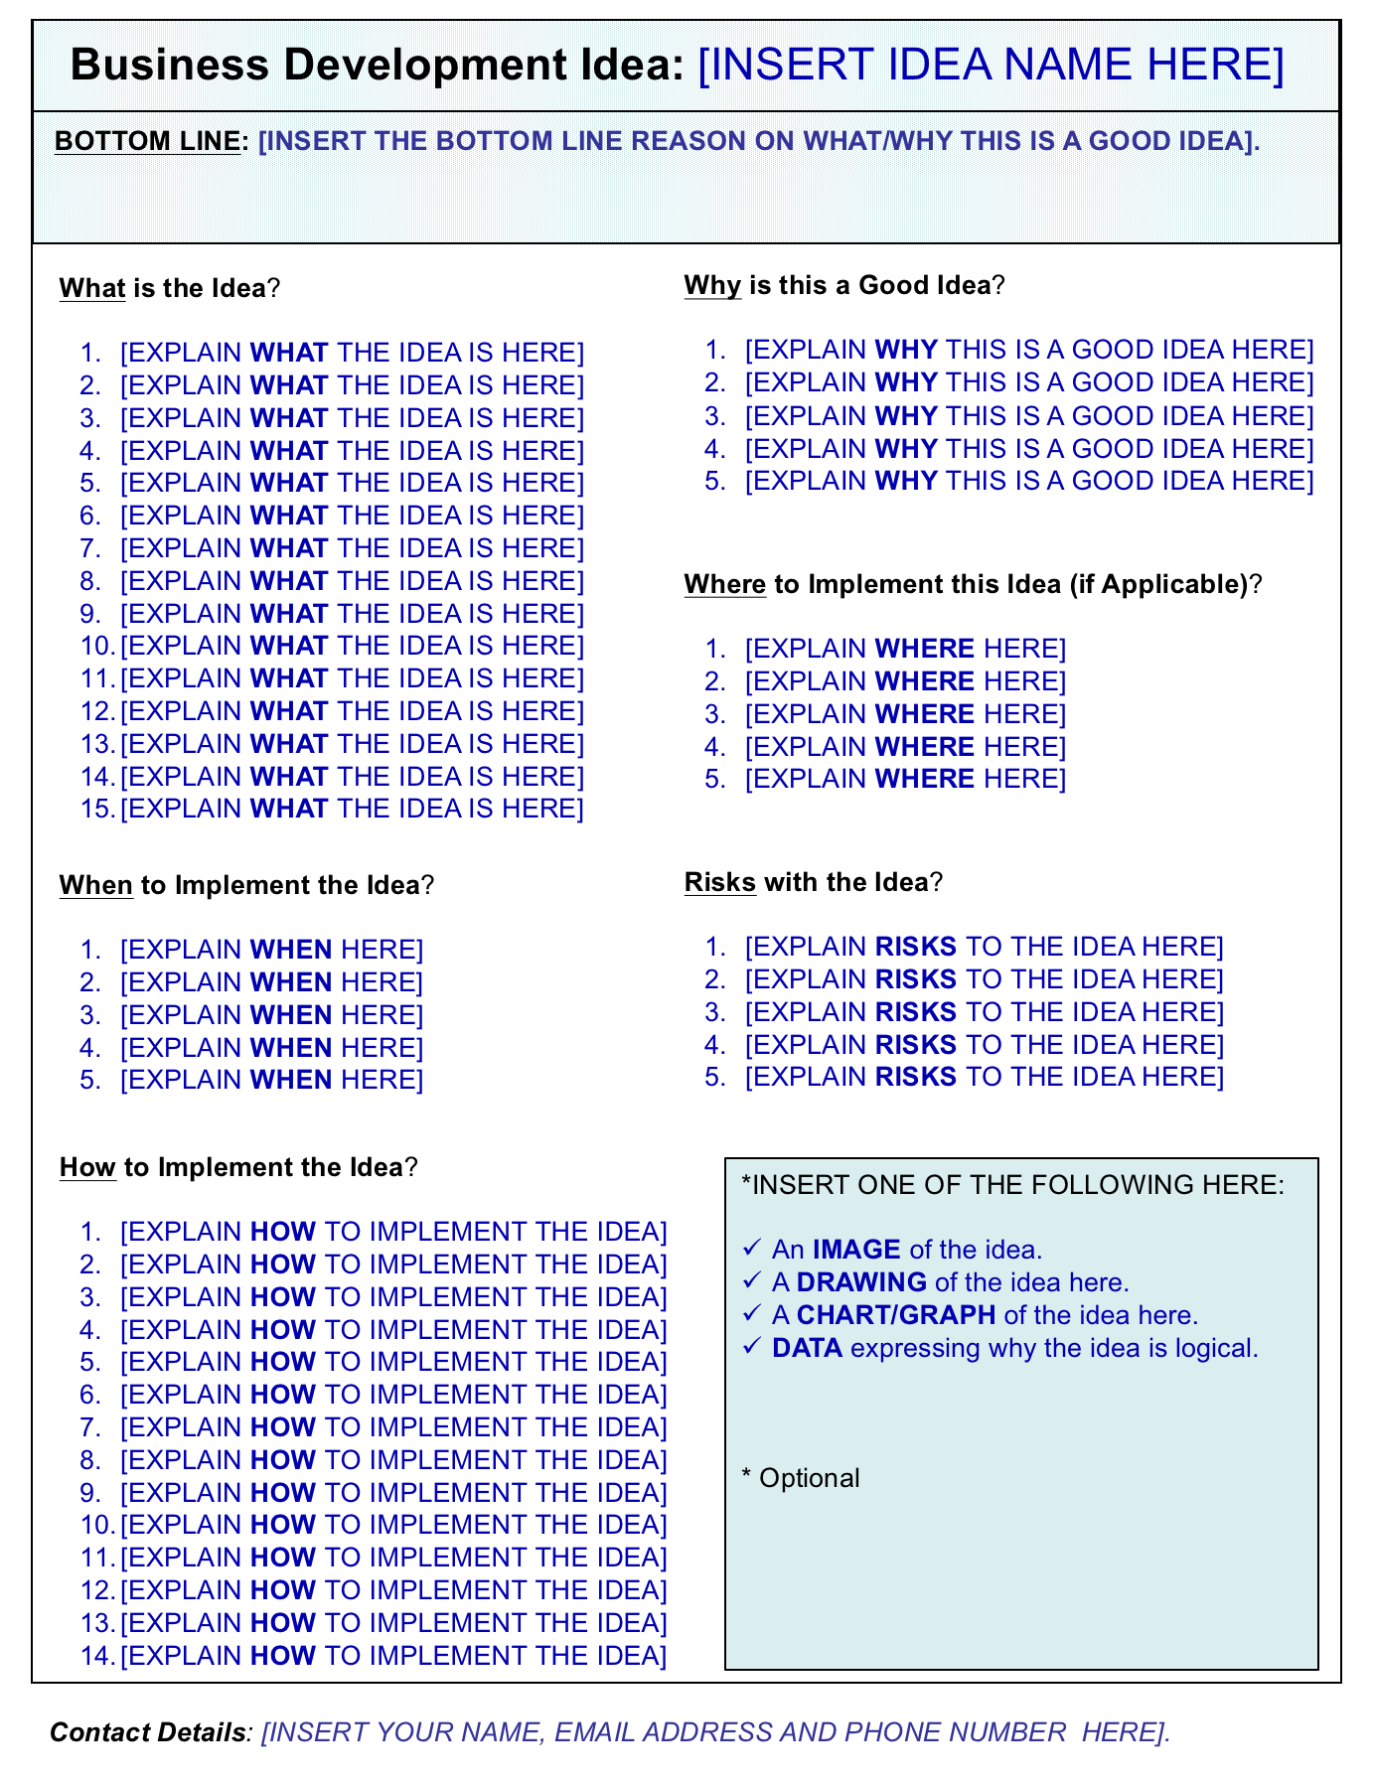

This document is attached to this lecture and is called: “**Template_Management_or_Business_Development_Interview.ppt**”  
In addition to printing this out and bringing multiple copies of it to your interview, you can save this document as a PDF in PowerPoint and email it to people you have already interviewed with in your Thank You email. Alternatively, as a follow up a few days after your interview or if it has been 1-2 weeks and you have not heard back from your interviewer(s), consider attaching this document in an email and sending it to the person/people that interviewed you [assuming you didn’t give them a paper copy in your interview]. You can also make a brand new one and send it to them that covers a different topic.

**Next Step:** Please watch the next video in the course before doing exercise 4.4. Thanks

* **Exercise 4.4: If you are interviewing for a sales job**, consider making or completing a template that lists potential sales leads that you have that will help the person interviewing you! Consider offering to introduce them to your sales leads during the interview when you give them this template….who does that? Nobody except you. Remember, every battle is won before it has been fought!

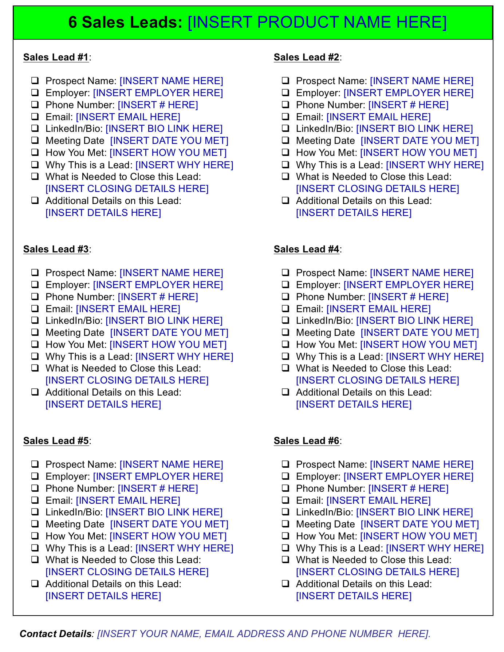

This document is attached to this lecture and is called: “**Template_Sales_Interview.ppt**”

In addition to printing this out and bringing multiple copies of it to your interview, you can save this document as a PDF in PowerPoint and email it to people you have already interviewed with in your Thank You email. Alternatively, as a follow up a few days after your interview or if it has been 1-2 weeks and you have not heard back from your interviewer(s), consider attaching this document in an email and sending it to the person/people that interviewed you [assuming you didn’t give them a paper copy in your interview]. You can also make a brand new one and send it to them that covers a different topic.

**Next Step:** Please watch the next video in the course before doing exercise 4.5. Thanks

* **Exercise 4.5: If you are interviewing for an operations job**, consider making or completing a template that shows cool forward thinking web cloud based tools that make the job functions easier, cheaper and more intuitive….or just helpful. Search the web for ideas. How do you find these ideas? It’s easy – search Google for this: “Cloud Based X.” X = the job function you are interviewing for. Once you find the cool new products, then try a free version (if available), then mention it in your interview with your thoughts on the pros and cons of using it and show this attached completed template (and the product on your smart phone, if applicable):

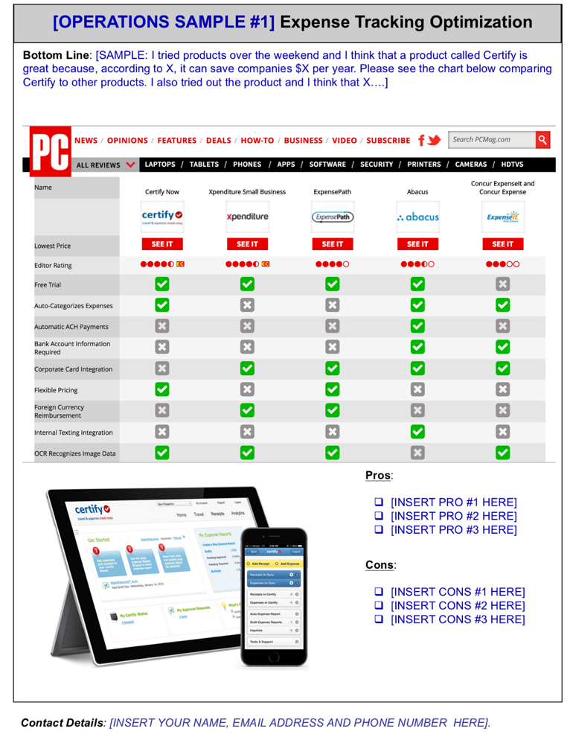

This document is attached to this lecture and is called: “**Template_Operations_1_Interview.ppt**”

In addition to printing this out and bringing multiple copies of it to your interview, you can save this document as a PDF in PowerPoint and email it to people you have already interviewed with in your Thank You email. Alternatively, as a follow up a few days after your interview or if it has been 1-2 weeks and you have not heard back from your interviewer(s), consider attaching this document in an email and sending it to the person/people that interviewed you [assuming you didn’t give them a paper copy in your interview]. You can also make a brand new one and send it to them that covers a different topic.

Here is another example of accounting software that you might have tried that is very efficient: 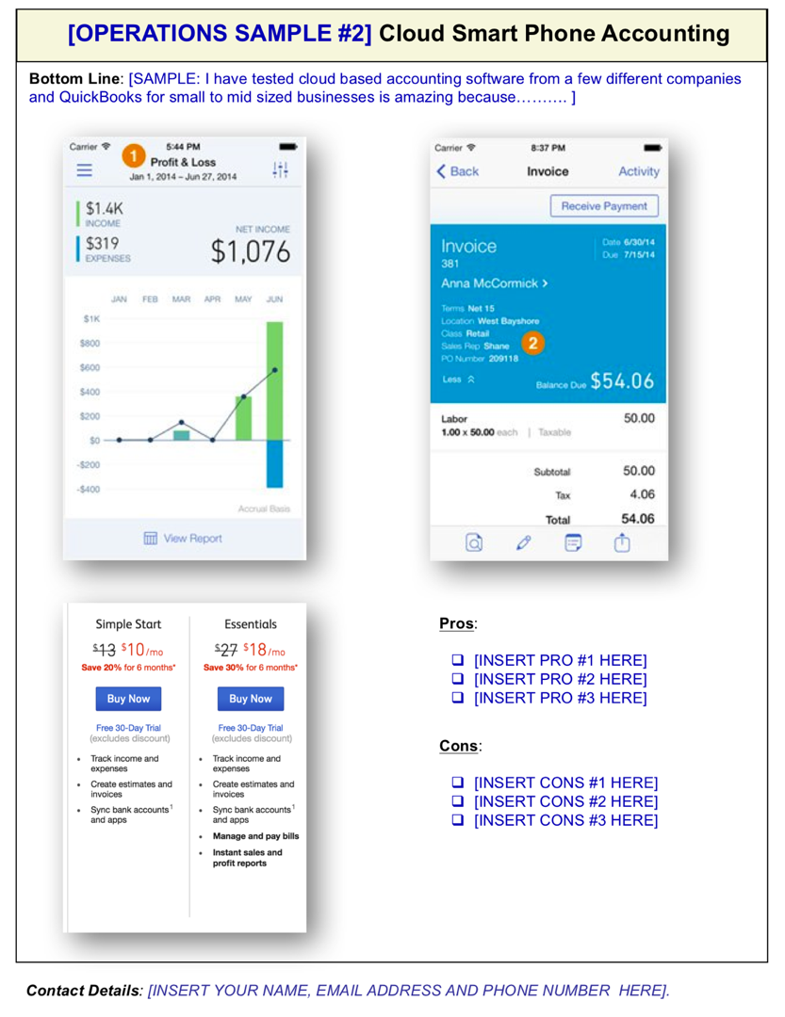

This document is attached to this lecture and is called: “**Template_Operations_2_Interview.ppt**”

In addition to printing this out and bringing multiple copies of it to your interview, you can save this document as a PDF in PowerPoint and email it to people you have already interviewed with in your Thank You email. Alternatively, as a follow up a few days after your interview or if it has been 1-2 weeks and you have not heard back from your interviewer(s), consider attaching this document in an email and sending it to the person/people that interviewed you [assuming you didn’t give them a paper copy in your interview]. You can also make a brand new one and send it to them that covers a different topic.

**Next Step:** Please watch the next video in the course before doing exercise 4.6. Thanks **Exercise 4.6: If you are interviewing for an assistant job**, consider making or completing a template that lists cool forward thinking tools that can make your boss even more organized. For example, a virtual assistant idea to be additive to your productivity:

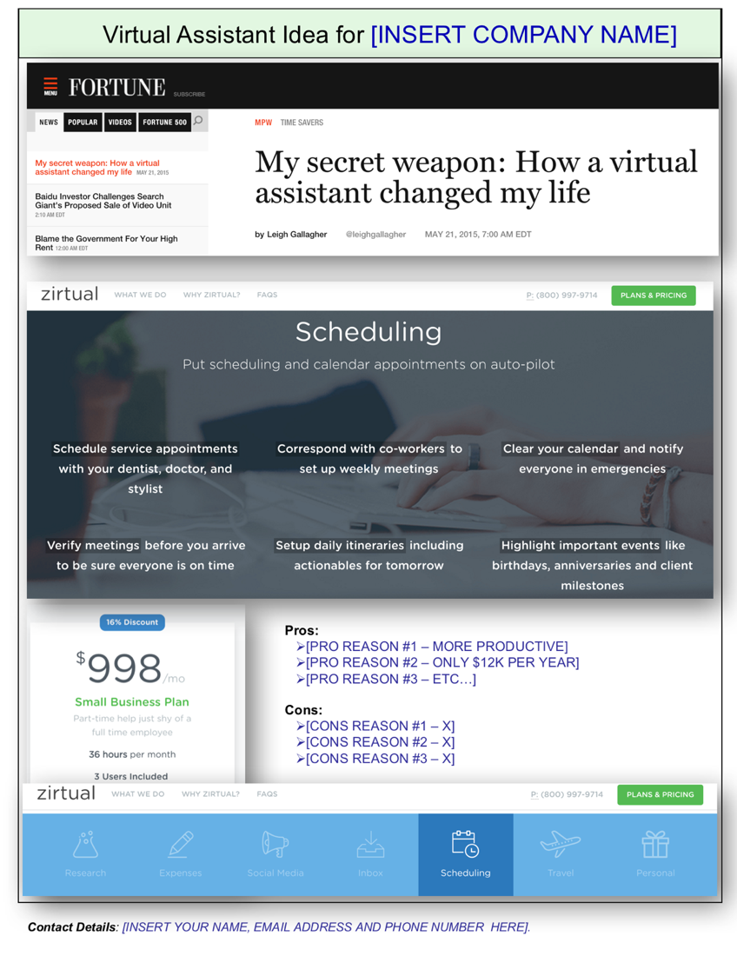

This document is attached to this lecture and is called: “**Template_Assistant_Interview.ppt**”  
In addition to printing this out and bringing multiple copies of it to your interview, you can save this document as a PDF in PowerPoint and email it to people you have already interviewed with in your Thank You email. Alternatively, as a follow up a few days after your interview or if it has been 1-2 weeks and you have not heard back from your interviewer(s), consider attaching this document in an email and sending it to the person/people that interviewed you [assuming you didn’t give them a paper copy in your interview]. You can also make a brand new one and send it to them that covers a different topic.

**Next Step:** Please watch the next video in the course before doing exercise 4.7. Thanks

* **Exercise 4.7: If you are interviewing for a human resources job**, show how forward thinking you are by trying out cool cloud based human resources tools like LinkedIn Talent Solutions that are used by human resource professionals (you can try it for free at this link: [https://business.linkedin.com/talent-solutions#](https://business.linkedin.com/talent-solutions) ):

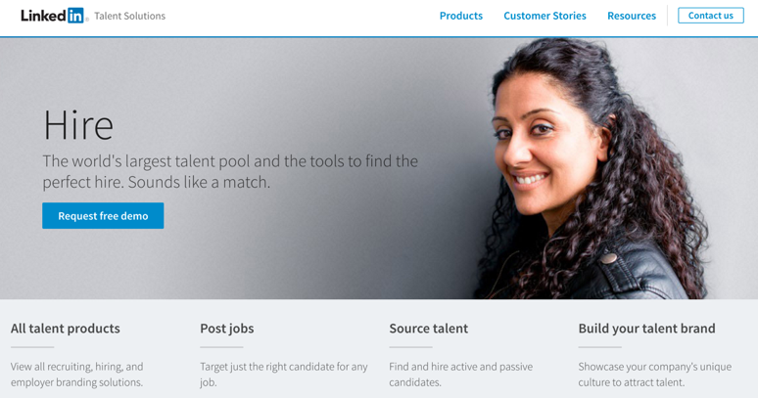

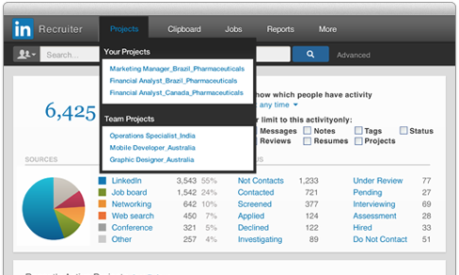

* Also check out [Glassdoor.com](http://glassdoor.com/) and find out what people are saying about the management of a competitor and be ready to discuss this in the interview. For example, if you are interviewing for a human resources job at a competitor to General Electric, read and discuss some of the employee reviews from Glassdoor.com about what the feedback is from employees (great competitive intelligence idea): <https://www.glassdoor.com/Reviews/GE-Reviews-E277.htm>
* Below is another template idea you can fill out and bring to your human resources interview: Do an ‘advanced search’* in LinkedIn & search for employees that used to work at the company you are interviewing for and see if you can find interesting patterns to share in the interview (for example, several employees left to go to business school or to competitor X or to companies in a completely different sector):

*\* Please note: we will cover more advanced LinkedIn functionality in Part 2 of the course, which covers resume/LinkedIn creation/optimization/optional goal setting workshop, S.E.O. (search engine optimization) & much more.*

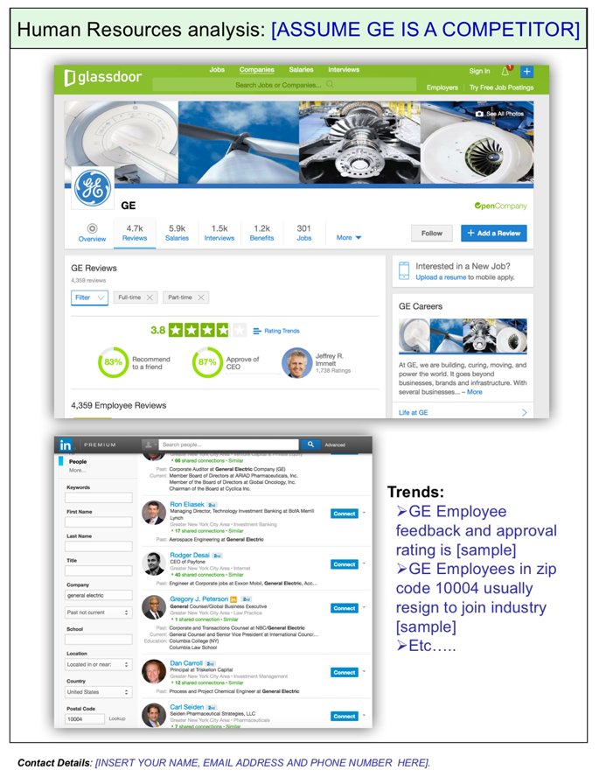

This document is attached to this lecture and is called:   
“**Template_** **Human_Resources_Interview.ppt.**” In addition to printing this out and bringing multiple copies of it to your interview, you can save this document as a PDF in PowerPoint and email it to people you have already interviewed with in your Thank You email. Alternatively, as a follow up a few days after your interview or if it has been 1-2 weeks and you have not heard back from your interviewer(s), consider attaching this document in an email and sending it to the person/people that interviewed you [assuming you didn’t give them a paper copy in your interview]. You can also make a brand new one and send it to them that covers a different topic.

**Next Step:** Please watch the next video in the course before doing exercise 4.8. Thanks

* **Exercise 4.8: If you are interviewing for a job position that I have not mentioned in this section or that you are unsure about**, then make a few templates based on the templates already discussed in and attached to this section.

**Bottom Line: Why are we bothering to create template exhibits to bring to the interview? Because your competition will not!**

**Next Step**: We are getting there! Now we know what to bring to the interview, how to discuss our weaknesses and how to discuss our strengths. We still need to talk about how to structure answers with logic and easy to use transition words and words that buy you time. However, before we do that, I want to discuss how to answer questions when you have no clue what the answer is or if you freeze (which you won’t). Please watch the next video in the course before doing the next exercise. Thanks

## **Section #5**:

## Answer Any Question that You Have No Idea How to Answer & Using Frameworks **exercise #5.1:**

## Memorize the ‘How to Answer Questions When you Are Lost’ Template

I really want you to memorize and practice over and over and over again how to use the “I am lost template” (show below) because it really helps you to answer literally any question if you are stuck/lost. Repetition is the mother of all skill; please repeat using this framework over and over again.

Later in the course we will cover recording yourself and practicing with others to see how you sound. For now, we are more focused on the content of your interview and less focused on the delivery process.



**Next Step:** Please watch the next video in the course before doing exercise 5.2. Thanks

**Interview Journal Exercise 5.2: Optional: Complete this Additional Template.**

If you are interviewing for a marketing position, a business development, a very senior level position, a consulting position or if you want to create an additional template to show that you can think strategically when it comes to addressing business problems or opportunities, please also complete the following template, which is also attached to this lecture:

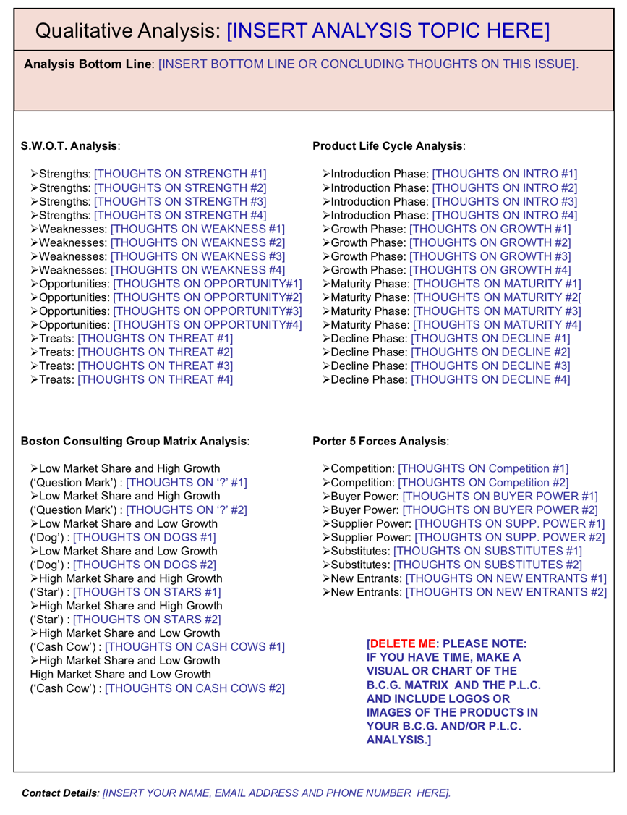

This document is attached to this lecture and is called:   
“**Template_** **Qualitative_Analysis_Interview.ppt.**” In addition to printing this out and bringing multiple copies of it to your interview, you can save this document as a PDF in PowerPoint and email it to people you have already interviewed with in your Thank You email. Alternatively, as a follow up a few days after your interview or if it has been 1-2 weeks and you have not heard back from your interviewer(s), consider attaching this document in an email and sending it to the person/people that interviewed you [assuming you didn’t give them a paper copy in your interview]. You can also make a brand new one and send it to them that covers a different topic.

**Next Step:** Please watch the next video in the course before doing the next exercise. Thanks

## **Section #6**:

## What You Must Know About the Company That Is Interviewing You

## **exercise #6:** Checklist of What You Need to Know About the Firm

At my Goldman Sachs interview, I was asked what the name of the CEO and CFO was. I had no idea what the CFO’s name was. Here is a checklist of what sources you need to review online as well as what basic things about the company you need to know:

Check the boxes once you review the source in preparation for your interview:

* I read the company’s Wikipedia Page.
* *I skimmed the company’s annual report from [www.sec.gov](http://www.sec.gov) if available.
* **I reviewed information about the company on [Glassdoor.com](http://glassdoor.com/).
* I search in [LinkedIn.com](http://linkedin.com/) & familiarized myself with the types of people that work at the firm.
* I know the name of the CEO and it is: ______________________.
* I know the name of the CFO and it is: ______________________.
* The founder of the company (on the Wikipedia page) is: ______________________.
* The largest competitor of the company is: ______________________.
* List 5 interesting things about the company that I learned through my research:
  + 1: ___________________________________________.
  + 2: ___________________________________________.
  + 3: ___________________________________________.
  + 4: ___________________________________________.
  + 5: ___________________________________________.
* I set up a Google Alert for the company so I can get daily alerts on news flow on the  
  company at <https://www.google.com/alerts> .
* *I have skimmed a few recent press releases from the company from their website.
* I subscribed to the company’s Twitter feed.
* *I listened to the company’s most recent investor earnings call (if available).

* Only complete if the company is publicly traded (meaning if it is listed on a stock market).

** Smaller companies won’t appear on Glassdoor.com

**Next Step:** Please watch the next video in the course before doing the next exercise. Thanks

## **Section #7**:

## Bond With the Interviewer First! **exercise #7.1 and #7.2:**

## List 2 Things You Have In Common With Them

**Interview Journal Exercise #7.1: List 2 Things You Have In Common With Them**

Obviously don’t tell the people that you will be interviewing with that you did this, but let’s find 2 things that you have common with each person that will be interviewing you. If you don’t know for sure who will be interviewing you, go to LinkedIn and find out which people work in the same department as others that might be interviewing you and quickly look at their LinkedIn profiles for 2 things that stand out to you [if you don’t know how to navigate advanced LinkedIn searches etc., this will be covered in Part 2 of this course].

For example, if you both like tennis, then be prepared to talk about tennis if they bring up what are your interests.

Another example, if you love baseball and they are from New York City, then talk about the New York Yankees baseball team or their former star shortstop Derek Jeter etc.,

**Please go to LinkedIn and write down 2 things that you might have in common with:**

|  |
| --- |
| **The name of the first potential interviewer is:** |
| Item #1 we have in common: |
| Item #2 we have in common: |

|  |
| --- |
| **The name of the second potential interviewer is:** |
| Item #1 we have in common: |
| Item #2 we have in common: |

|  |
| --- |
| **The name of the third potential interviewer is:** |
| Item #1 we have in common: |
| Item #2 we have in common: |

|  |
| --- |
| **The name of the fourth potential interviewer is:** |
| Item #1 we have in common: |
| Item #2 we have in common: |

|  |
| --- |
| **The name of the fifth potential interviewer is:** |
| Item #1 we have in common: |
| Item #2 we have in common: |

|  |
| --- |
| **The name of the sixth potential interviewer is:** |
| Item #1 we have in common: |
| Item #2 we have in common: |

|  |
| --- |
| **The name of the seventh potential interviewer is:** |
| Item #1 we have in common: |
| Item #2 we have in common: |

|  |
| --- |
| **The name of the eight potential interviewer is:** |
| Item #1 we have in common: |
| Item #2 we have in common: |

|  |
| --- |
| **The name of the ninth potential interviewer is:** |
| Item #1 we have in common: |
| Item #2 we have in common: |

|  |
| --- |
| **The name of the tenth potential interviewer is:** |
| Item #1 we have in common: |
| Item #2 we have in common: |

I promise you that there is no way that your competition completed this past exercise!

**Interview Journal Exercise #7.2: Questions to Remember to Pass the O'Hare Test**

1: Do they enjoy your company?

2: Do they spend more time talking than you do?

3: Do they enjoy answering your questions and telling you their life story?

4. Do they trust you?

I wrote a more detailed article in my Inc.com column on this test: <http://www.inc.com/chris-haroun/4-questions-you-must-answer-to-close-a-sale-or-get-hired.html>

**Next Step:** Please watch the next video in the course before doing the next exercise. Thanks

## **Section #8**:

## Transition Words, Words to Use, Words Not to Use and Words That Buy You Time! **exercise #8:**

## Using Transition Words to Structure Your Logic and Buy Time

You don’t only have to use the transition words or the “buy me time” words that I mentioned in this section, but I want you to be ready to use them if you have a lot to say and you want to structure your logic or if you need filler words to buy you a little more time so you can think of the best way to answer the question. Also, there is a tactful way to express disagreement in an interview (per the video lecture).

The answers to these questions are on the next page.

**Question #1**: If you disagree with someone, rather than say “I don’t agree with you,” you might

want to say: ________________________________________________.

**Question #2**: You need to buy a bit more time in order to answer this question that the interviewer asks you: “*Please tell me why you haven’t interviewed with our biggest competitor whose headquarters is very close to where you grew up?*” You could consider answering this question by prefacing it with a phrase like this that buys you some time:

__________________________________________________________________________.

**Question #3:** You are about to provide a lengthy answer to a question that has 4 parts to it.

What transition word(s) can you use between part 1 and part 2: ____________

What transition word(s) can you use between part 2 and part 3: ____________

What transition word(s) can you use between part 3 and part 4: ____________

**Answers to the questions in this section:**

**Answer to Question #1**: “I used to feel that way, but I felt differently when I found out that….” [FEEL, FELT, FOUND OUT].

**Answer to Question #2:** “That’s a great question [smile a bit]; the reason that I haven’t interviewed or ever applied to work for them is that ….[remember don’t say anything negative about the competition].”

**Answer to Question #3:**

“In terms of…”

“Moving on to…”

“Lastly, …”

You can also start the first part of the answer with “I’ll kick it off with….”

**Next Step:** Please watch the next video in the course before doing the next exercise. Thanks

*Please note: There are no exercises in Section #9…the title of Section #9 should be a hint why : )*

## **Section #10**:

## How to Know What the Next Question is That They Will Ask You? **exercise #10:**

## Answering Questions the Preemptive & Logical Strategic Way

Please create 5 answers to questions that interviewers might ask you and then consider their follow up question and answer their follow up question.

For example:

**Interviewer’s Question:** “*Why did you attend X university?”*

**Your Initial Answer:** *“Because it has the best liberal arts program out of all of the universities that I visited.”*

**The Interviewer’s Follow Up Question:** *“What other universities did you visit?”*

**Your Follow Up Answer:** *“I also visited X and Y universities and I felt that….”*

|  |  |
| --- | --- |
| Interviewer’s Question #1: |  |
| Your Initial Answer to Question #1: |  |
| The Interviewer’s Follow Up Question: |  |
| Your Follow Up Answer: |  |

|  |  |
| --- | --- |
| Interviewer’s Question #2: |  |
| Your Initial Answer to Question #2: |  |
| The Interviewer’s Follow Up Question: |  |
| Your Follow Up Answer: |  |

|  |  |
| --- | --- |
| Interviewer’s Question #3: |  |
| Your Initial Answer to Question #3: |  |
| The Interviewer’s Follow Up Question: |  |
| Your Follow Up Answer: |  |

|  |  |
| --- | --- |
| Interviewer’s Question #4: |  |
| Your Initial Answer to Question #4: |  |
| The Interviewer’s Follow Up Question: |  |
| Your Follow Up Answer: |  |

|  |  |
| --- | --- |
| Interviewer’s Question #5: |  |
| Your Initial Answer to Question #5: |  |
| The Interviewer’s Follow Up Question: |  |
| Your Follow Up Answer: |  |

**Next Step:** Please watch the next video in the course before doing the next exercise. Thanks

## **Section #11**:

## Practice Answering These Tough Questions **exercise #11:**

## Journal Exercise #11: Answering These Tough Questions.

**Every Battle is Won Before it Has Been Fought**. As such, let’s write down answers to some of the toughest questions that an interviewer can ask us. If you want my humble thoughts on how to answer these questions, please watch Section #11 before answering these questions. Think about how to answer tough questions to make you look like the ideal candidate and be humble. Thanks

|  |
| --- |
| Question: Why Do You Want to Leave Your Current Company? |
|  |

|  |
| --- |
| Question: I Don't Think You Are Qualified for this Job. Convince Me That You Are. |
|  |

|  |
| --- |
| Question: Why Were You Fired? [if applicable] |
|  |

|  |
| --- |
| Question: What is Your Weakness? |
|  |

|  |
| --- |
| Question: What is Your Strength? |
|  |

|  |
| --- |
| Question: Tell Me About Yourself. |
|  |

|  |
| --- |
| Question: Do You Have Something on Your Record We Should Know About? |
|  |

|  |
| --- |
| Question: How Much Does a 747 Weigh? |
|  |

|  |
| --- |
| Question: Why Are Construction Hole Covers Round? |
|  |

|  |
| --- |
| Question: You Own a Parking Lot and Your Competitor Across the Street Just Cut their Price by 50%. You Can’t Cut Your Price. What Would You Do to Remain Competitive? |
|  |

|  |
| --- |
| Question: What is Your Biggest Failure? |
|  |

|  |
| --- |
| Question: How Do You Exceed Client Expectations? |
|  |

|  |
| --- |
| Question: Why Didn't You Go To Harvard? |
|  |

|  |
| --- |
| Question: Are there Visa Issues If You Get the Job? |
|  |

|  |
| --- |
| Question: I Hate Where You Are From? [I can’t believe that jerk asked me this question! You don’t have to bother responding to this one…just be ready if you have a hostile interviewer, who is likely putting on an act to see how you respond under pressure.] |
|  |

|  |
| --- |
| Question: What is Your #1 Investment Idea. No I Mean Your #2 Best Idea….No I Mean Your #3 Best Idea? |
|  |

For the next 35 questions, have your resume in your hand (if you don’t have one, complete the resume portion of this course and then come back to this question). Assuming your resume has 35 lines on it, I want you to ask yourself 35 questions about each line on your resume in the next 35 questions. For example, tell me about [insert line item #x]. As always, keep your answers short and answer with the strength keywords that we have covered in this course.

|  |
| --- |
| Resume Line Item Question: Tell me About [line item #1]? |
|  |

|  |
| --- |
| Resume Line Item Question: Tell me About [line item #2]? |
|  |

|  |
| --- |
| Resume Line Item Question: Tell me About [line item #3]? |
|  |

|  |
| --- |
| Resume Line Item Question: Tell me About [line item #4]? |
|  |

|  |
| --- |
| Resume Line Item Question: Tell me About [line item #5]? |
|  |

|  |
| --- |
| Resume Line Item Question: Tell me About [line item #6]? |
|  |

|  |
| --- |
| Resume Line Item Question: Tell me About [line item #7]? |
|  |

|  |
| --- |
| Resume Line Item Question: Tell me About [line item #8]? |
|  |

|  |
| --- |
| Resume Line Item Question: Tell me About [line item #9]? |
|  |

|  |
| --- |
| Resume Line Item Question: Tell me About [line item #10]? |
|  |

|  |
| --- |
| Resume Line Item Question: Tell me About [line item #11]? |
|  |

|  |
| --- |
| Resume Line Item Question: Tell me About [line item #12]? |
|  |

|  |
| --- |
| Resume Line Item Question: Tell me About [line item #13]? |
|  |

|  |
| --- |
| Resume Line Item Question: Tell me About [line item #14]? |
|  |

|  |
| --- |
| Resume Line Item Question: Tell me About [line item #15]? |
|  |

|  |
| --- |
| Resume Line Item Question: Tell me About [line item #16]? |
|  |

|  |
| --- |
| Resume Line Item Question: Tell me About [line item #17]? |
|  |

|  |
| --- |
| Resume Line Item Question: Tell me About [line item #18]? |
|  |

|  |
| --- |
| Resume Line Item Question: Tell me About [line item #19]? |
|  |

|  |
| --- |
| Resume Line Item Question: Tell me About [line item #20]? |
|  |

|  |
| --- |
| Resume Line Item Question: Tell me About [line item #21]? |
|  |

|  |
| --- |
| Resume Line Item Question: Tell me About [line item #22]? |
|  |

|  |
| --- |
| Resume Line Item Question: Tell me About [line item #23]? |
|  |

|  |
| --- |
| Resume Line Item Question: Tell me About [line item #24]? |
|  |

|  |
| --- |
| Resume Line Item Question: Tell me About [line item #25]? |
|  |

|  |
| --- |
| Resume Line Item Question: Tell me About [line item #26]? |
|  |

|  |
| --- |
| Resume Line Item Question: Tell me About [line item #27]? |
|  |

|  |
| --- |
| Resume Line Item Question: Tell me About [line item #28]? |
|  |

|  |
| --- |
| Resume Line Item Question: Tell me About [line item #29]? |
|  |

|  |
| --- |
| Resume Line Item Question: Tell me About [line item #30]? |
|  |

|  |
| --- |
| Resume Line Item Question: Tell me About [line item #31]? |
|  |

|  |
| --- |
| Resume Line Item Question: Tell me About [line item #32]? |
|  |

|  |
| --- |
| Resume Line Item Question: Tell me About [line item #33]? |
|  |

|  |
| --- |
| Resume Line Item Question: Tell me About [line item #34]? |
|  |

|  |
| --- |
| Resume Line Item Question: Tell me About [line item #35]? |
|  |

Every battle is won before it has been fought.

**Next Step:** Please watch the next video in the course before doing the next exercise. Thanks

## **Section #12**:

## Why You Need to Think Like Your Interviewer and Help Them With Their Career **exercise #12:**

## How Can You Help Your Interviewer's Career?

If you know who will be interviewing you, then write down their name and their title in the spaces below. Answer one question about each person you will be interviewing with. If you have no idea who you will be interviewing with, then either visit the company’s website and check out the About section or use LinkedIn and search for people that work at the company in the same department and location that you will be interviewing at. If it’s a sales person, then be ready to share sales introductions or leads with them. If it’s a Human Resources person, be ready to share other exhibits with them. Remember how you prepared exhibits to give some interviewers? Have those handy to give to them if applicable. If you focus on helping their career and/or helping them get more revenue and/or helping them cut expenses, then they will really appreciate this.

|  |  |
| --- | --- |
| Interviewer #1 Name: |  |
| Interviewer #1 Title: |  |
| Interviewer #1 Department: |  |
| What exhibit(s) that we have created already can we give interviewer #1 to potentially enhance or help their careers or to make them more productive: |  |
| If giving interviewer #1 an exhibit isn’t appropriate, what can we say or do or follow up with after the interview to help them with their careers (i.e., introduce them to a sales lead or send them an interesting article via email that will help them in their careers): |  |

|  |  |
| --- | --- |
| Interviewer #2 Name: |  |
| Interviewer #2 Title: |  |
| Interviewer #2 Department: |  |
| What exhibit(s) that we have created already can we give interviewer #2 to potentially enhance or help their careers or to make them more productive: |  |
| If giving interviewer #2 an exhibit isn’t appropriate, what can we say or do or follow up with after the interview to help them with their careers (i.e., introduce them to a sales lead or send them an interesting article via email that will help them in their careers): |  |

|  |  |
| --- | --- |
| Interviewer #3 Name: |  |
| Interviewer #3 Title: |  |
| Interviewer #3 Department: |  |
| What exhibit(s) that we have created already can we give interviewer #3 to potentially enhance or help their careers or to make them more productive: |  |
| If giving interviewer #3 an exhibit isn’t appropriate, what can we say or do or follow up with after the interview to help them with their careers (i.e., introduce them to a sales lead or send them an interesting article via email that will help them in their careers): |  |

|  |  |
| --- | --- |
| Interviewer #4 Name: |  |
| Interviewer #4 Title: |  |
| Interviewer #4 Department: |  |
| What exhibit(s) that we have created already can we give interviewer #4 to potentially enhance or help their careers or to make them more productive: |  |
| If giving interviewer #4 an exhibit isn’t appropriate, what can we say or do or follow up with after the interview to help them with their careers (i.e., introduce them to a sales lead or send them an interesting article via email that will help them in their careers): |  |

|  |  |
| --- | --- |
| Interviewer #5 Name: |  |
| Interviewer #5 Title: |  |
| Interviewer #5 Department: |  |
| What exhibit(s) that we have created already can we give interviewer #5 to potentially enhance or help their careers or to make them more productive: |  |
| If giving interviewer #5 an exhibit isn’t appropriate, what can we say or do or follow up with after the interview to help them with their careers (i.e., introduce them to a sales lead or send them an interesting article via email that will help them in their careers): |  |

|  |  |
| --- | --- |
| Interviewer #6 Name: |  |
| Interviewer #6 Title: |  |
| Interviewer #6 Department: |  |
| What exhibit(s) that we have created already can we give interviewer #6 to potentially enhance or help their careers or to make them more productive: |  |
| If giving interviewer #6 an exhibit isn’t appropriate, what can we say or do or follow up with after the interview to help them with their careers (i.e., introduce them to a sales lead or send them an interesting article via email that will help them in their careers): |  |

|  |  |
| --- | --- |
| Interviewer #7 Name: |  |
| Interviewer #7 Title: |  |
| Interviewer #7 Department: |  |
| What exhibit(s) that we have created already can we give interviewer #7 to potentially enhance or help their careers or to make them more productive: |  |
| If giving interviewer #7 an exhibit isn’t appropriate, what can we say or do or follow up with after the interview to help them with their careers (i.e., introduce them to a sales lead or send them an interesting article via email that will help them in their careers): |  |

|  |  |
| --- | --- |
| Interviewer #8 Name: |  |
| Interviewer #8 Title: |  |
| Interviewer #8 Department: |  |
| What exhibit(s) that we have created already can we give interviewer #8 to potentially enhance or help their careers or to make them more productive: |  |
| If giving interviewer #8 an exhibit isn’t appropriate, what can we say or do or follow up with after the interview to help them with their careers (i.e., introduce them to a sales lead or send them an interesting article via email that will help them in their careers): |  |

|  |  |
| --- | --- |
| Interviewer #9 Name: |  |
| Interviewer #9 Title: |  |
| Interviewer #9 Department: |  |
| What exhibit(s) that we have created already can we give interviewer #9 to potentially enhance or help their careers or to make them more productive: |  |
| If giving interviewer #9 an exhibit isn’t appropriate, what can we say or do or follow up with after the interview to help them with their careers (i.e., introduce them to a sales lead or send them an interesting article via email that will help them in their careers): |  |

|  |  |
| --- | --- |
| Interviewer #10 Name: |  |
| Interviewer #10 Title: |  |
| Interviewer #10 Department: |  |
| What exhibit(s) that we have created already can we give interviewer #10 to potentially enhance or help their careers or to make them more productive: |  |
| If giving interviewer #10 an exhibit isn’t appropriate, what can we say or do or follow up with after the interview to help them with their careers (i.e., introduce them to a sales lead or send them an interesting article via email that will help them in their careers): |  |

**Next Step:** Please watch the next video in the course before doing the next exercise. Thanks

## **Section #13**:

## Additional Crucial Strategies to Address in Interviews **exercise #13:**

## Why Everything You've Done Leads Up to this Job

Quite often interviewers look at your resume and think that there is a lack of consistency in what you have done in the past and why this is the perfect job for you. For example, you might be interviewing for an engineering job and you have a liberal arts education and not an engineering one. In this case, you can state that Steve Jobs also had a liberal arts education [he dropped out even] and how your background is additive to the job you are interviewing for, etc.

Look at your resume (or think of your history) and (if possible) explain 10 things on your resume that will help you excel in the job you are interviewing for:

|  |  |
| --- | --- |
| 1: Resume Item: |  |
| Why this resume item will help you excel in the role you are interviewing for: |  |

|  |  |
| --- | --- |
| 2: Resume Item: |  |
| Why this resume item will help you excel in the role you are interviewing for: |  |

|  |  |
| --- | --- |
| 3: Resume Item: |  |
| Why this resume item will help you excel in the role you are interviewing for: |  |

|  |  |
| --- | --- |
| 4: Resume Item: |  |
| Why this resume item will help you excel in the role you are interviewing for: |  |

|  |  |
| --- | --- |
| 5: Resume Item: |  |
| Why this resume item will help you excel in the role you are interviewing for: |  |

|  |  |
| --- | --- |
| 6: Resume Item: |  |
| Why this resume item will help you excel in the role you are interviewing for: |  |

|  |  |
| --- | --- |
| 7: Resume Item: |  |
| Why this resume item will help you excel in the role you are interviewing for: |  |

|  |  |
| --- | --- |
| 8: Resume Item: |  |
| Why this resume item will help you excel in the role you are interviewing for: |  |

|  |  |
| --- | --- |
| 9: Resume Item: |  |
| Why this resume item will help you excel in the role you are interviewing for: |  |

|  |  |
| --- | --- |
| 10: Resume Item: |  |
| Why this resume item will help you excel in the role you are interviewing for: |  |

**Next Step:** Please watch the next video in the course before doing the next exercise. Thanks

## **Section #14**:

## Body Language, Tone, Voice Modulation and Demeanor During the Interview **exercise #14:**

## Improving Body Language When Answering Questions

Please video record yourself (i.e., with your smart phone) answering as many questions as possible from this Interview Success Journal and then check the following boxes below after watching yourself answering the questions to make sure that your body language is optimized for the interview (per the lectures in Section #14):

* Eye Contact: Make sure that you look left and right every now and then (per the video lecture on this topic), look down only occasionally. Never look above the interviewer. Make sure to break eye contact at least once per minute.

|  |  |
| --- | --- |
| Optional Comments: |  |

* Shaking Hands: [tough to video this one] Make sure you have a medium grip (not too hard and never too soft). Look the interviewer in the eyes while shaking their hand, smile and say “great meeting you; thanks a lot for your time.” Be aware of cross cultural differences. For example, the bowing and business card exchange process in Japan.

|  |  |
| --- | --- |
| Optional Comments: |  |

* Do You Stand Whenever the Interviewer Does and Use the Right Seating Posture?

|  |  |
| --- | --- |
| Optional Comments: |  |

* Do You Sound Too Confident?

|  |  |
| --- | --- |
| Optional Comments: |  |

* Do You Sound Not Confident Enough?

|  |  |
| --- | --- |
| Optional Comments: |  |

* Do You Use Filler Words Too Often like “um” and “ah”?

|  |  |
| --- | --- |
| Optional Comments: |  |

* Do You Sound Interesting and Engaging?

|  |  |
| --- | --- |
| Optional Comments: |  |

* Are You Smiling Enough or Do You Look Too Serious?

|  |  |
| --- | --- |
| Optional Comments: |  |

* Do You Sound Humble and Occasionally Self Deprecating (slightly poking fun of yourself). Both of the aforementioned qualities are ones that people admire.

|  |  |
| --- | --- |
| Optional Comments: |  |

* Additional Observed Body Language Comments:

|  |  |
| --- | --- |
| Optional Comments: |  |

*Please note: there are no exercises in Sections #15 and #16.*

**Next Step:** Please watch the next video in the course before doing the next exercise. Thanks

## **Section #17**:

## Strategies Based on the Seniority of the Person Interviewing You **exercise #17:**

## Interviewing With Executives from Different Levels

Please feel free to skip this section, if you didn’t have enough time to complete some/all of the templates/1 pagers mentioned earlier in the course. Before completing this section, please make sure to watch all of the videos in Section #17. If you made a number of exhibits/templates as mentioned in earlier sessions of this course, then please decide which exhibits you have made that you will share with which executives (this might seem a bit repetitive, but it is intentional based on the lectures on seniority/rank in this section). Thanks

|  |  |
| --- | --- |
| Interviewer #1 Name: |  |
| Interviewer #1 Title: |  |
| What exhibits to share with this interviewer or with interviewers at this level: |  |
|  |
|  |

|  |  |
| --- | --- |
| Interviewer #2 Name: |  |
| Interviewer #2 Title: |  |
| What exhibits to share with this interviewer or with interviewers at this level: |  |
|  |
|  |

|  |  |
| --- | --- |
| Interviewer #3 Name: |  |
| Interviewer #3 Title: |  |
| What exhibits to share with this interviewer or with interviewers at this level: |  |
|  |
|  |

|  |  |
| --- | --- |
| Interviewer #4 Name: |  |
| Interviewer #4 Title: |  |
| What exhibits to share with this interviewer or with interviewers at this level: |  |
|  |
|  |

|  |  |
| --- | --- |
| Interviewer #5 Name: |  |
| Interviewer #5 Title: |  |
| What exhibits to share with this interviewer or with interviewers at this level: |  |
|  |
|  |

|  |  |
| --- | --- |
| Interviewer #6 Name: |  |
| Interviewer #6 Title: |  |
| What exhibits to share with this interviewer or with interviewers at this level: |  |
|  |
|  |

|  |  |
| --- | --- |
| Interviewer #7 Name: |  |
| Interviewer #7 Title: |  |
| What exhibits to share with this interviewer or with interviewers at this level: |  |
|  |
|  |

|  |  |
| --- | --- |
| Interviewer #8 Name: |  |
| Interviewer #8 Title: |  |
| What exhibits to share with this interviewer or with interviewers at this level: |  |
|  |
|  |

|  |  |
| --- | --- |
| Interviewer #9 Name: |  |
| Interviewer #9 Title: |  |
| What exhibits to share with this interviewer or with interviewers at this level: |  |
|  |
|  |

|  |  |
| --- | --- |
| Interviewer #10 Name: |  |
| Interviewer #10 Title: |  |
| What exhibits to share with this interviewer or with interviewers at this level: |  |
|  |
|  |

**Next Step:** Please watch the next video in the course before doing the next exercise. Thanks

## **Section #18**:

## Questions to Ask In The Interviews **exercise #18:**

## What Questions to Ask Based On Their Levels

Before completing this section, please make sure to watch all of the videos in Section #18. In this exercise, please write down which questions you will ask which executives you will be meeting with and other notes you might have on strategies for the interviews listed below:

|  |  |
| --- | --- |
| Interviewer #1 Name: |  |
| Interviewer #1 Title: |  |
| What questions to ask this interviewer or with interviewers at this level: |  |
|  |
|  |

|  |  |
| --- | --- |
| Interviewer #2 Name: |  |
| Interviewer #2 Title: |  |
| What questions to ask this interviewer or with interviewers at this level: |  |
|  |
|  |

|  |  |
| --- | --- |
| Interviewer #3 Name: |  |
| Interviewer #3 Title: |  |
| What questions to ask this interviewer or with interviewers at this level: |  |
|  |
|  |

|  |  |
| --- | --- |
| Interviewer #4 Name: |  |
| Interviewer #4 Title: |  |
| What questions to ask this interviewer or with interviewers at this level: |  |
|  |
|  |

|  |  |
| --- | --- |
| Interviewer #5 Name: |  |
| Interviewer #5 Title: |  |
| What questions to ask this interviewer or with interviewers at this level: |  |
|  |
|  |

|  |  |
| --- | --- |
| Interviewer #6 Name: |  |
| Interviewer #6 Title: |  |
| What questions to ask this interviewer or with interviewers at this level: |  |
|  |
|  |

|  |  |
| --- | --- |
| Interviewer #7 Name: |  |
| Interviewer #7 Title: |  |
| What questions to ask this interviewer or with interviewers at this level: |  |
|  |
|  |

|  |  |
| --- | --- |
| Interviewer #8 Name: |  |
| Interviewer #8 Title: |  |
| What questions to ask this interviewer or with interviewers at this level: |  |
|  |
|  |

|  |  |
| --- | --- |
| Interviewer #9 Name: |  |
| Interviewer #9 Title: |  |
| What questions to ask this interviewer or with interviewers at this level: |  |
|  |
|  |

|  |  |
| --- | --- |
| Interviewer #10 Name: |  |
| Interviewer #10 Title: |  |
| What questions to ask this interviewer or with interviewers at this level: |  |
|  |
|  |

**Next Step:** Please watch the next video in the course before doing the next exercise. Thanks

## **Section #19**:

## What to Do the Morning of the Interview (Before the Interview) **exercise #19:**

## What To Do The Morning of The Interview Checklist

Make sure that during the morning of the interview that you complete most of the following tasks (please watch the videos in this section before completing this exercise):

* Get into a peak mental state by:  
  + Listening to inspirational music.
  + Eating breakfast that does not leave you tired (non greasy).
  + Don’t consume too much caffeine.
  + Meditate for 10 minutes with deep slow breathing and think about a time in your life when you were so confident and happy and in a perfect state (I want you to maintain this state throughout the day of the interview).
  + Say a prayer if you want to [as God already knows what is going to happen – this should stop you from worrying about anything at all]!
  + Be grateful for 10 things in your life right now.
  + Think of how much your friends and family love you and want you to do well and enjoy the ~~interviews~~ meetings.
* Research any news that might be relevant that morning pertaining to the company you will be interviewing with (in case they ask you) by accessing the following sources:  
  + Do a Google search on the company name [search news releases in Google] .
  + Read the Twitter feed of the company you will be interviewing with.
  + Go to the company’s website to see if they posted a new news release item(s).
  + Go to CNN.com/BBC.com, etc. and quickly see what the top news items are [for casual conversation ideas with one of the people interviewing you]. Also go to the most popular news site of the city/region/country that you are based in.
  + If you are interviewing for a finance job, read the highlights from the Wall Street Journal and Financial Times. If you are interviewing for a job in another industry, then read news sites that morning that are relevant to the company you are interviewing with.

* Other / miscellaneous preparation ideas:  
  + Set 2 alarms to wake you up (and if you are at a hotel, ask for 2 wakeup calls).
  + If you have never been to the location of the company that you will be meeting at, go the day before so you know how long it takes you to get there (I know this seems like a bit much but I have done everything you see in this section for all of my interviews that I have gotten the job offer for). I have to quote my father by saying *“don’t ever take a shortcut that you have never taken before when you are in a hurry!”*
  + Order a taxi well in advance of the interview or drive or take public transportation so you arrive 1 hour early (don’t go into the company’s office until 5 minutes before the interview).
  + Please see Section 4 of this Interview Success Journal and make sure that you packed all of the items mentioned in Section 4 for your interview and please don’t forget your ID as many buildings have security desks that request your ID.
  + If are not sure what the dress code is, overdress and then ask security on the main level what the dress code is and ditch the tie, jacket etc. if you want (have security watch it for you – they are usually very cool and happy to help you….remember to be very nice to all of the assistants too obviously).

**Next Step:** Please watch the next video in the course before doing the next exercise. Thanks

## **Section #20**:

## What to Do Immediately After the Interview **exercise #20:** What To Do Immediately After The Interview Checklist

Make sure to complete the following items immediately after your interview (in the order listed below). It’s important to do this right away as there is a good chance that your interviewers won’t submit their thoughts on you until the end of the day…..and if you get to them first with a thank you email then this might influence the feedback that they provide their Human Resources department about you:

* Send thank you emails to everyone that interviewed you. If you got business cards from only some of the people that interviewed you, then look at the email format and send emails to other people who didn’t give you a business card. For example, if you got a business card from Arthur Jones and it was [Arthur.Jones@CompanyName.com](mailto:Arthur.Jones@CompanyName.com) but not from someone named Bill Haddad, then try sending an email to Bill at: [Bill.Haddad@CompanyName.com](mailto:Bill.Haddad@CompanyName.com) . If the email to Bill bounces, then try: [William.Haddad@CompanyName.com](mailto:William.Haddad@CompanyName.com) or [Will.Haddad@CompanyName.com](mailto:Will.Haddad@CompanyName.com) etc. If all of the email addresses that you try don’t work, then write a handwritten note and mail it that night (very nice personal touch that most people don’t do unfortunately anymore…remember we are trying to stand out here and really connect with them).   
  + The contents for all thank you emails can be like this example, but change them a little bit to customize for the person you met with (in case one interviewer forwards your thank you email to the team….you will look more authentic/sincere if you change up the thank you emails a bit). For example use the following formats:   
    - Subject Line = Thanks. Message contents:   
        
      John,  
        
      Great meeting with you today; I enjoyed our conversation. Here is the article I mentioned in the meeting: [www.samplewebsite123.com](http://www.samplewebsite123.com)   
        
      Thanks a lot for your time,  
      Chris  
      [www.YourLinkedInProfile123.com](http://www.YourLinkedInProfile123.com)
    - Subject Line = Thank you. Message contents:   
        
      Steve,  
        
      It was great meeting with you today; thank you for your time. In terms of X topic that we discussed, my thoughts are X.  
        
      Thanks again,  
      Chris   
      [www.YourLinkedInProfile123.com](http://www.YourLinkedInProfile123.com)
    - Subject Line = Nice Meeting You. Message contents:   
        
      Sandra,  
        
      I enjoyed our conversation today. Here is the article I mentioned in the meeting: [www.samplewebsite123.com](http://www.samplewebsite123.com)   
        
      Thanks a lot for your time,  
      Chris

[www.YourLinkedInProfile123.com](http://www.YourLinkedInProfile123.com)

* + - Subject Line = Thanks for the Meeting. Message contents:   
        
      Mo,  
        
      Wonderful meeting with you today; I really enjoyed our conversation. In terms of the question that I said I would follow up on, here is the answer….X.   
        
      Many thanks and have a great weekend,  
      Chris   
      [www.YourLinkedInProfile123.com](http://www.YourLinkedInProfile123.com)
    - Subject Line = You WILL Hire Me (that was a Jedi Mind Trick) …... Message contents:   
        
      Marc or is it Mark?,  
        
      I can’t remember if I should spell Marc with a C or a K.. So when you go to Starbucks and you give them your name when you order a coffee, does the cup that they write your name on look like this?   
        
      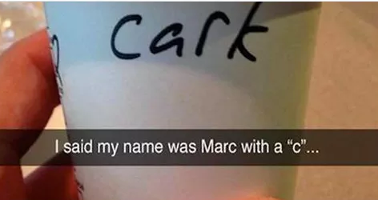   
        
      Chris with a C (not a K). [www.YourLinkedInProfile123.com](http://www.YourLinkedInProfile123.com)   
      [please see the green highlighted text on the next page : )
    - Subject Line = You Better Hire Me Or Else…... Message contents:   
        
      Mister Benjamin Dover or do your friends call you Ben?,  
        
      The smartest darn thing you could ever do is hire me or else your company will go bankrupt.   
        
      Your future boss,  
      Chris   
       [www.YourLinkedInProfile123.com](http://www.YourLinkedInProfile123.com)
    - I want to make sure you are paying attention as the last two were jokes : )

Please document as many things as you can recall about each interview you had in case you interview with other people later in the company (you can cite things you spoke about with other candidates….makes you look networked and proactive):

|  |  |
| --- | --- |
| Interviewer #1 Name: |  |
| Interviewer #1 Title: |  |
| What do you recall from the interview with interviewer #1: |  |
|  |
|  |
|  |
|  |
|  |
|  |
|  |
|  |
|  |

|  |  |
| --- | --- |
| Interviewer #2 Name: |  |
| Interviewer #2 Title: |  |
| What do you recall from the interview with interviewer #2: |  |
|  |
|  |
|  |
|  |
|  |
|  |
|  |
|  |
|  |

|  |  |
| --- | --- |
| Interviewer #3 Name: |  |
| Interviewer #3 Title: |  |
| What do you recall from the interview with interviewer #3: |  |
|  |
|  |
|  |
|  |
|  |
|  |
|  |
|  |
|  |

|  |  |
| --- | --- |
| Interviewer #4 Name: |  |
| Interviewer #4 Title: |  |
| What do you recall from the interview with interviewer #4: |  |
|  |
|  |
|  |
|  |
|  |
|  |
|  |
|  |
|  |

|  |  |
| --- | --- |
| Interviewer #5 Name: |  |
| Interviewer #5 Title: |  |
| What do you recall from the interview with interviewer #5: |  |
|  |
|  |
|  |
|  |
|  |
|  |
|  |
|  |
|  |

|  |  |
| --- | --- |
| Interviewer #6 Name: |  |
| Interviewer #6 Title: |  |
| What do you recall from the interview with interviewer #6: |  |
|  |
|  |
|  |
|  |
|  |
|  |
|  |
|  |
|  |

|  |  |
| --- | --- |
| Interviewer #7 Name: |  |
| Interviewer #7 Title: |  |
| What do you recall from the interview with interviewer #7: |  |
|  |
|  |
|  |
|  |
|  |
|  |
|  |
|  |
|  |

|  |  |
| --- | --- |
| Interviewer #8 Name: |  |
| Interviewer #8 Title: |  |
| What do you recall from the interview with interviewer #8: |  |
|  |
|  |
|  |
|  |
|  |
|  |
|  |
|  |
|  |

|  |  |
| --- | --- |
| Interviewer #9 Name: |  |
| Interviewer #9 Title: |  |
| What do you recall from the interview with interviewer #9: |  |
|  |
|  |
|  |
|  |
|  |
|  |
|  |
|  |
|  |

|  |  |
| --- | --- |
| Interviewer #10 Name: |  |
| Interviewer #10 Title: |  |
| What do you recall from the interview with interviewer #10: |  |
|  |
|  |
|  |
|  |
|  |
|  |
|  |
|  |
|  |

**Next Step:** Please watch the next video in the course before doing the next exercise. Thanks

## **Section #21**:

## You Got the Job, Now What? **exercise #21:**

## What to Write in Your "Moving On" Email/LinkedIn Update

Before you leave your current company, send out an email to every business contact (and select friends & family members). BCC everyone on the email and be complementary and positive. Everyone has their own style, but here is one I used via email when I resigned to start my venture capital company and for my LinkedIn Update (we will discuss LinkedIn in Part 2 and Part 3 of this course in great detail):

**Email Subject Line**: Moving On + New Contact Details and Passion : )

**Email Contents**:

Dear Friends,

I am writing to let you know about my exciting new venture capital firm. First of all, I want to thank my family at X [ X = the company you are resigning from] for their unconditional love, support and friendship over the past few years. My new email address is [x@gmail.com](mailto:charoun@gmail.com) .

I am following my passion, which is education/tech/charity as I really think that all problems in the world can be solved using education and technology. As such, I am launching Haroun Education Ventures to help students *“dream bigger with a passion to learn, earn and return with no limits.”*

I am humbled to say that my board is composed of the following people that share my passion for embracing education and technology to solve all problems:

Gus Hunt, former CTO of the CIA.

Jawad Nabulsi who started the Arab spring and is the quintessential human rights activist.

Franklin Urteaga who worked in the White House where he started the successful ‘computers for all in underprivileged schools’ initiative.

Brenda Ibanescu, founder of Providing Opportunities for Women.

David, Ali, Ali and Lilika from [www.LEMOfoundation.org](http://www.LEMOfoundation.org) which provides scholarships and tutoring for students in East Palo Alto, where the high school graduation rate is only 40%.

Manoj Govindan who is a senior executive at Wells Fargo and shares our passion for education; Manoj is very much involved in mentoring and helping students to realize their full potential.

Sharon Kedar, CFO of Sands Capital and best-selling author and mentor to many.

Again I want to thank my family at X. If you need to reach anyone at X, please contact X at email address [x@x.com](mailto:x@x.com)

Thanks : )

Chris

Chris Haroun

[www.linkedin.com/in/charoun](http://www.linkedin.com/in/charoun)

**Next Step:** Please watch the next video in the course before doing the next exercise. Thanks

## **Section #22**:

## What if You Don't Get the Job & When to Turn Down the Offer **exercise #22:**

## How to Respond to a Rejection Via Email

Your best contacts in business might very well be people that you interviewed with that (for whatever reason) did not offer you the job. Here is how I have responded in the past and this has helped my career big time as the people I interviewed with are huge investors or partners of mine:

**Rejection Email Subject Line**: Thanks

**Email Contents**:

John,

I just wanted to say that I really enjoyed meeting with you and your colleagues. If I can be resourceful to you in any way, please let me know.

Thanks and have a great weekend,

Chris

Chris Haroun

[www.linkedin.com/in/charoun](http://www.linkedin.com/in/charoun)

**Congratulations**!!!! You are now better prepared than literally anyone that has ever interviewed at the company you will be interviewing with (VERY TRUE – especially with the completed templates). This should give you the confidence to enjoy and do exceptionally well in your interview!

Please read your completed Interview Success Journal a few days before and the morning of your interview. Please enjoy the interview too! You have prepared so much for it that you should get the same feeling while you are interviewing as you do when you are writing an exam that you are more prepared for than ANYONE else!

There are no limits to what you can achieve!

If you are taking this course in order, please watch the next video to start working on creating/improving your resume and optimizing your LinkedIn profile so that you are noticed by more and more recruiters. There is also an optional goal setting workshop in the next part of the course (which is part 2 of 3) which I highly and humbly recommend completing. After you complete the resume and LinkedIn section, please do part 3, which will help you network better than anybody and help your career take off big time!!!!

Thank you very much for your time, dedication and commitment,  
Chris : )



***Please find your passion and live love life on your terms. : )***